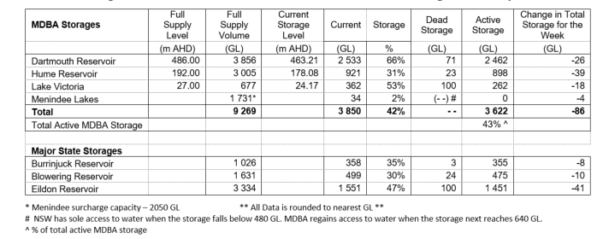



Remove state storeages and link to River Murray Data page

Add link below to Snowy website

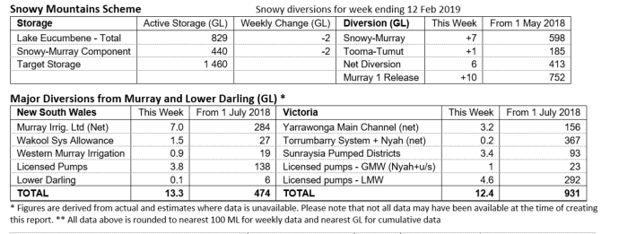



Remove EC table and replace with links to River Murray Data

Remove river levels and flow table and replace with link to River Data site

Remove natural inflow to Hume

Remove locks and weir table and add link to South Aus weekly report and DEWNR website

Remove Lower talks table and add link to SA weekly report, plus put the lower lakes levels in the weekly report words.

Remove Barrages and fish way table and keep words in the text.

Let SA know we’re going to remove from our report.

Look at options to update graphs

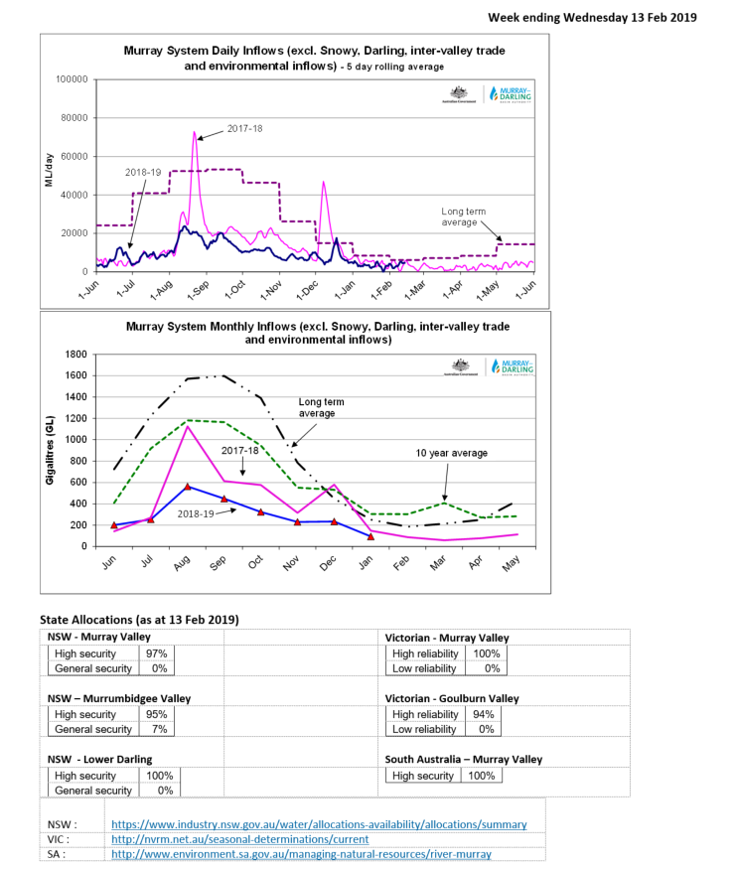

If space is an issue, could simplify State allocations table.